http://0.tqn.com/d/usmilitary/1/0/L/a/are4corp.gifhttp://0.tqn.com/d/usmilitary/1/0/I/a/afe4.jpg

DELAWARE NATIONAL GUARD

JOINT ENLISTED ASSOCIATION BARBECUE

**SATURDAY, SEPTEMBER 19, 2015**

**12 PM TO 3 PM**

**RSVP BY AUGUST 14TH 2015**

**NETWORKING, FUN, GAMES AND FOOD FOR ALL**

C:\Documents and Settings\donzella.johnson\Local Settings\Temporary Internet Files\Content.IE5\532R696Q\MC900135195[1].wmf

**COME ONE, COME ALL!!! LET THIS BE OUR BEST YEAR EVER!**

**FOOD, CONVERSATION, NATIONAL GUARD UPDATES, FUN FOR YOUNG AND OLD**

**FAMILY AND FRIENDS ARE WELCOME**

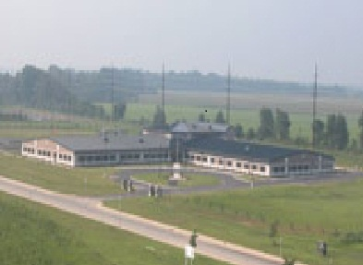

***WHERE: SMYRNA READINESS CENTER***

***103 ARTISAN DRIVE, SMYRNA, DE 19977***

***(RAIN OR SHINE)***

**SPONSORED BY THE**

**DELAWARE NATIONAL GUARD ARMY/AIR RETIRED ENLISTED ASSOCIATION**

**AND THE**

**DELAWARE NATIONAL GUARD ENLISTED ASSOCIATION**

**Donzella Johnson Dwight Lacy Jaquita Nesbit**

[**Donzella.johnson@gmail.com**](mailto:Donzella.johnson@gmail.com)[**lacy1d@msn.com**](mailto:lacy1d@msn.com) **jaquita.d.nesbit.mil@mail.mil**

**302-399-0458**

NAME ____________________________________________ NUMBER OF QUESTS ____________________________________

Number of Children ____________________________ Ages ____________________________________________________

ORGANIZATION ______________________ FOOD ITEM ______________________ or DONATION AMOUNT________________

**NOTE: Not yet a member of the Enlisted or the Retired Association, no worries. I have attached a membership form for each and you can mail in or bring with you the day of the Barbecue.**